**A PROJECT REPORT**

**ON**

**ONLINE ATTENDANCE TRACKER**



*Submitted By*

NAME ID

MD. Rakibul Islam 11708020

Helal Hossain 11708007

Ashikur Rahman Showrov 11708008

Ahsan Habib 11708011

Syed Ashraf Asif 11708009

**COMILLA UNIVERSITY :: CUMILLA – 3506**

# BONAFIDE CERTIFICATE

This is to certify that the project entitled, “**ONLINE ATTENDANCE TRACKER**”

and submitted by “**MD. Rakibul Islam, Helal Hossain, Ashikur Rahman**

**Showrov, Ahsan Habib, Syed Ashraf Asif**” in partial fulfillment of the requirements

of CSE 3108 Project Work embodies the work done by them under my supervision.

|  |
| --- |
|  |

**SIGNATURE SIGNATURE**

|  |  |
| --- | --- |
| **MD. HASAN HAFIZUR RAHMAN** | **NAYAN BANIK** |
|  |  |
| **CHAIRMAN, EXAM COMMITTEE** | **SUPERVISOR** |
| Assistant Professor | Lecturer |
| Department of  Computer Science and Engineering  Comilla University, Cumilla | Department of  Computer Science and Engineering  Comilla University, Cumilla |
|  |  |
|  |  |

i

# 

## DECLARATION

We hereby declare that the project report entitled “**Online Attendance Tracker**” submitted by us to **Computer Science and Engineering** department **Comilla University, Cumilla** in partial fulfillment for the award of degree of Bsc in computer science and engineering is a record of bonafide project work carried out by us under the guidance of **Nayan Banik (Lecturer)**.

We further declare that the work reported in this project has not been submitted and will not be submitted, either in part or full, for the award of any other degree in this institute or any other institute or University.

|  |  |
| --- | --- |
| MD. Rakibul Islam | (11708020) |
| Helal Hossen | (11708007) |
| Ashikur Rahman Showrov | (11708008) |

Ahsan Habib (11708011)

Syed Ashraf Asif (11708009)

ii

# Abstract

# "Online attendance tracker" is an online-based system where attendance will be tracked by an online system. There will be an option for both student and teacher so that every student and teacher can get their respective subject attendance information. Online attendance tracker deal with the maintenance of the student’s attendance details. It is generates the attendance of the student on basis of presence in class. It is maintaining daily basis of attendance. The staff handling the particular subject to responsible to make the attendance for all students. Only if the student presents the particular date, the attendance will be calculated. The student attendance report based on monthly and consolidate will be generated.

iii

# Acknowledgements

At first, we want to express gratitude to the Almighty Allah for His endless kindness for keeping us mentally and physically fit to complete this project.

This project would not get its own shape without the support of the institution, Comilla University, which provided us the chance for a Bachelor's Program in computer science and engineering. This project is an aggregate of the co-operation of many people.

Foremost, we would like to express my deepest gratitude to our honorable supervisor, NAYAN BANIK. His vast knowledge, attitude, behavior, and wisdom are have given us the strength to work harder every day. His directions and guidelines for preparing manuscripts, reports, and presentations made us more dynamic and well-organized throughout the whole project. He gave us enough time from the beginning of the project, though he has a tough schedule of his own task.

# 

# 

iv

# Contents

Certificate i

Declaration ii

Abstract iii

Acknowledgement iv

Contents v

List of Figures vi

1. Introduction 1

1.1 Motivation…………………………………………… 2

1.2 Problem Statement…………………………………... 2

1.3 Aims and Objective……………………………….. 3

1.4 Overview The System………………………………… 5

2. Literature Review 6

2.1 Overview of Existing System………………………… 6

2.2 Proposed System……………………………………… 6

2.3 Used Technology……………………………………… 9

2.4. Software Description and programing language……… 9

3. Methodology and Design 11

3.1 Data Flow Diagram……………………………………. 11

3.2 E-R Diagram……………………………………………. 11

3.3 Database Tables 14

4. Implementation and Result 15

5. Conclusion22

**References** 23

v

**List Of Figures**

3.1 Data Flow Diagram…………………………………………11

3.2 E-R Diagram………………………………………………...12

3.3 Objects Table………………………………………………..14

3.4 Teacher Tables………………………………………………14

4.1 Homepage…………………………………………………...15

4.2 Teacher Dashboard………………………………………….16

4.3 Teacher Homepage…………………………………………..17

4.4 Editing Class………………………………………………….18

4.5 Update Teacher Information………………………………….19

4.6 Attendance Sheet………………………………………………19

4.7 Student Statistics………………………………………………20

4.8 Student Dashboard…………………………………………….21

vi

**Chapter 1**

**Introduction**

"Online attendance tracker" is an online-based system where attendance will be tracked by an online system. There will be an option for both student and teacher so that every student and teacher can get their respective subject attendance information. This document is meant for describing all the features and procedures that were followed while developing the system. This document specially mentions the details of the project and how it was developed, the primary requirement, as well as various features And functionalities of the project and the procedures followed in achieving these objectives. Over the years the manual attendance management has been carried across most of educational institutions. To overcome the problems of manual attendance, we have developed “Online Attendance Tracker”. Attendance Management System is based on web server, which can be implemented on any computer. In This application, PHP is server side language, MySQL and PHP is used as back-end design and HTML, CSS and JavaScript are used as front-end tools. The system communicates with database residing on a remote server. It calculates automatically, the attendance percentage of students Without any manual paper-based work. The system facilitates the end users with interactive design and automated processing of attendance management. With the effective use, any Institute can apply the “Online Attendance Tracker” for conducting quick attendance and getting better results in less time.

1

### Motivation

We need to maintain attendance in college, university. It is hard to maintain this in the paper. So, the introduction of an online-based system consisting of easy management that tracks the attendance will be helpful for us. The present system of attendance tracking is a mostly manual and time-taking process. So, in order to overcome this problem; we need to create an online-based system so that it gets easy to maintain attendance. This system developed will reduce the manual work and avoid redundant data. By maintaining the attendance manually, then efficient reports cannot be generated. The system can generate efficient weekly, consolidate report based on the attendance. As the attendances are maintained in registers it has been a tough task for admin and staff to maintain for long time. Instead the software can keep long and retrieve the information when needed.

### 1.2 Problem Statement

### Usually, we get information from different articles from different websites about various topics. There is no platform that gathers all of our choices of information in one place and often lacks the view of the website to a smartphone format.

2

### 1.3 Aims and Objectives

This project aims at managing attendance details of students so that both students and teachers have all the attendance –related information of respective subjects and respective streams. The system should be designed in such a way that only authorized people should be allowed to access some particular modules. The records should be modified by only administrators and no one else. The user should always be in control of the application and not the vice versa. The user interface should be consistent so that the user can handle the application with ease and speed. The application should be visually, conceptually clear.

Create a Window application to be used in place of old paper based user attendance management process. Here we will get following benefits from our project:

• Use the technologies and Server technology used in here to create strong and secured database connectivity.

• Incorporate the server software within the code.

• Runtime package and deployment instructions are given.

• Eliminate duplicate data entry and errors in time and attendance entries .

• Eliminate paperwork and save time.

• Automatic calculation of attendance.

• To Increase security.

3

Uniqueness & Special features of our project

• Concrete functionalities:- Our software contains lots of functionalities in it each having specific operations to perform.

• Efficiency and accuracy This software developed is very fast, flexible, efficient and is 100% accurate.

• Frame work Contains a very special Frame work which was discussed below in software’s and technology used.

• Web Services Web service is a service offered by an electronic device to another electronic device, communicating with each other via the World Wide Web. In a Web service, Web technology such as HTTP, originally designed for humanto-machine communication, is utilized for machine-tomachine communication, more specifically for machine Attendance Management System readable file formats such as XML and JSON. In our Attendance Software, The Web service typically provides an object-oriented Web-based interface to database server, utilized by another Web server.

4

**1.4 Overview The System**

The product Attendances Management system is an independent product and does not depend on any other product or system. The product will automate various tasks associated with handling student details and better organizing the stored information and optimum performance, thus helping the Deapartment to ensure smooth working of these processes.Our system has two types of accessing modes:

• Teacher

• Student

Teacher: Teacher have rights to manage student details, add a new student, provide register number for all students, assign each student a course etc., Teacher can update his profile, and also can give help to the students.

Student: Student can see profile, Attendance Details etc. student.

5

**Chapter 2**

**Literature Review**

**2.1 Overview of Existing System**

Existing system is a manual entry for the students. Here the attendance will be carried out in the hand written registers. It will be a tedious job to maintain the record for the user. The human effort is more here. The retrieval of the information is not as easy as the records are maintained in the hand written registers. This application requires correct feed on input into the respective field. Suppose the wrong inputs are entered, the application resist to work. so the user find it difficult to use. There are some others project on this work. But there are some issued on those work. In them anyone can login or signup. But it is a major problem.

**2.2 Proposed System**

To overcome the drawbacks of the existing system, the proposed system has been evolved. This project aims to reduce the paper work and saving time to generate accurate results from the student’s attendance. The system provides with the best user interface.The efficient reports can be generated by using this proposed system.

#### Advantages of Proposed System:

It is trouble-free to use. It is a relatively fast approach to enter attendance is highly reliable, approximate result from user Best user Interface and efficient reports.

### 6

**2.3 Feasibility Analysis**

Feasibility analysis begins once the goals are defined. It starts by generating broad possible solutions, which are possible to give an indication of what the new system should look lime. This is where creativity and imagination are used. Analysts must think up new ways of doing things- generate new ideas. There is no need to go into the detailed system operation yet. The solution should provide enough information to make reasonable estimates about project cost and give users an indication of how the new system will fit into the organization. It is important not to exert considerable effort at this stage only to find out that the project is not worthwhile or that there is a need significantly change the original goal. Feasibility of a new system means ensuring that the new system, which we are going to implement, is efficient and affordable. There are various types of feasibility to be determined.

#### Economically Feasibility

Development of this application is highly economically feasible. The only thing to be done is making an environment with an effective supervision. It is cost effective in the sense that has eliminated the paper work completely. The system is also time effective because the calculations are automated which are made at the end of the month or as per the user requirement.

**7**

**Technical Feasibility**

The technical requirement for the system is economic and it does not use any other aaditional Hardware and software. Technical evaluation must also access whether the existing systems can be upgraded to use the new technology and whether the organization has the expertise to use it.

8

**2.3 Requirement Specifications**

### Hardware Requirements:-

#### RAM: 2 GB

Hard Disk: 500 GB

Processor: Intel core i3

### Software Requirements:-

### Operating System: Windows 10,7,8,9

Front-End Language : HTML, CSS, PHP

Back-End Language: Mysql

**2.4 Software Description and Programming Language**

**MySql**

The data in a database is organized into tables, and each table is organized into rows and columns. Each row in a table is called a record. A record may contains several pieces (called fields) of information, and each column in a table is known as a field. MS stands for Management System, the software that allows you to insert, retrieve, modify, or delete records. R stands for Relational, indicates a particular kind of DBMS that is good at relating information stored in one table to information stored in another table by looking for elements common to each of them. Relational DBMS has the advantage of efficient

9

storage, and retrieval mechanisms for data, and uses normalization process during design of RDBMS.( <https://www.w3schools.com/css/css_intro.asp>)

**PHP**

PHP is an acronym for "PHP: Hypertext Preprocessor". PHP is a widely-used, open source scripting language. PHP scripts are executed on the server. PHP is free to download and use. It is powerful enough to be at the core of the biggest blogging system on the web. It is deep enough to run the largest social network. It is also easy enough to be a beginner’s first server side language. PHP can generate dynamic page content. PHP can create, open, read, write, delete, and close files on the server. PHP can collect form data. PHP can send and receive cookies. PHP can add, delete, modify data in your database. PHP can be used to control user-access. PHP can encrypt data. (<https://www.w3schools.com/php/php_intro.asp>)

**CSS**

**CSS** stands for **C**ascading **S**tyle **S**heets CSS describes how HTML elements are to be displayed on screen, paper, or in other media. (<https://www.w3schools.com/css/css_intro.asp>)

10

**Chapter 3**

**Methodology and Design**

**3.1** [**Data Flow Diagram(DFD)**](https://www.geeksforgeeks.org/levels-in-data-flow-diagrams-dfd/)**:**

Data means information, flow means to move, and diagram means a picture to represent something. So, DFD is simply the graphical representation of the flow of data or information. It is a framework or pattern of the data systems. It includes data input, data output, storing data. DFD describes the process of taking the data as input, storing the data, giving the data as output. DGD describes the path of data that completes the process.There are mainly two types of DFD: Physical Data Flow Diagram, and Logical Data Flow Diagram.

**3.2** [**Entity Relationship Diagram (ERD)**](https://www.geeksforgeeks.org/introduction-of-er-model/)**:**

ERD is also known as the Entity-Relationship Model. ERD was originally proposed by Peter Chen. Entity means any object used to store information and are distinguishable, relationship means connection, and diagram/model means a picture uses to represent something. So, ERD is simply the diagram or model that is used to represent or show the relationship between the entities or data objects that are stored in a database. The main components of the E-R model are an entity, attributes, and relationship. It is a very easy way to represent the database design. (https://en.wikipedia.org/wiki/Entity%E2%80%93relationship_model)

11

### Data Flow Diagram (DFD)

Student Login

Teacher Login

Student Attendance

Management

**Fig 3.1: Zero Level DFD- Online Attendance Tracker**

Here are the Zero level DFD for our project. There are three module in our project. Teacher teached students and teacher takes attendance. In Zero-Level DFD there are basic connection between teacher and student module with our main project.

12

**E-R Diagram**

Teacher

Takess

Attendance

Teaches

Student

**Fig 3.2: E-R diagram for ONLINE ATTENDANCE TRACKER**

13

## 3.3 Database Tables

There are two tables in our database for “Online Attendance Tracker”. These are

•. objects

• teacher

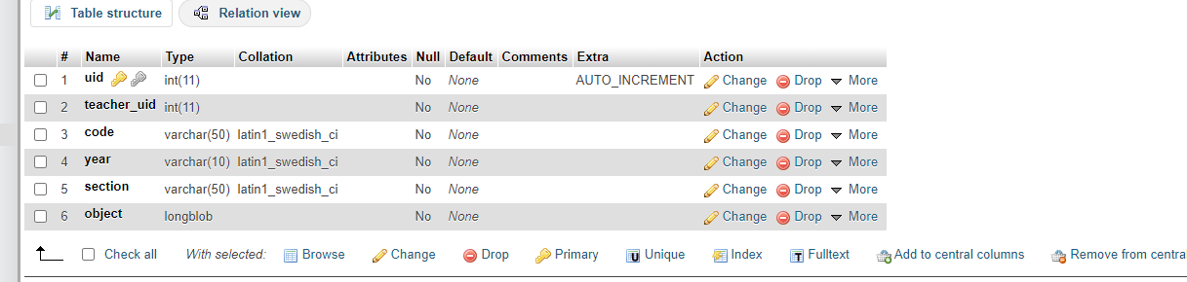

Fig 4.1: objects table structure

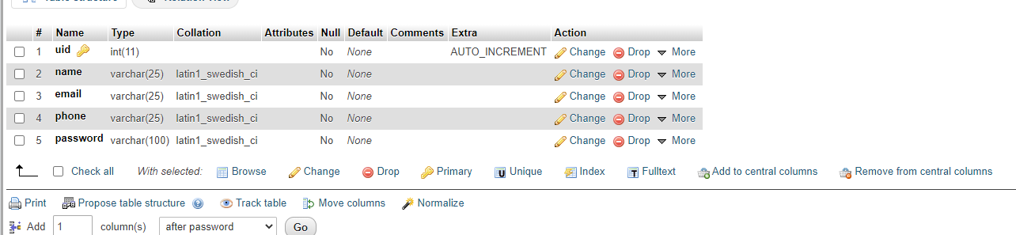

Fig 4.2: teacher table structure

14

## Chapter 4

## Implementation and Result

Implementation is the stage in the project where the theoretical design is turned into a working system. The implementation phase constructs install and operate the new system. The most crucial stage in achieving a new successful system is that it will work efficiently and effectively. Here is how this project will work- The attendance details of students from each class/stream are updated to the database of the web application on a daily basis. This task will be done on a daily basis by teachers for their respective subjects and classes using the student’s id. There will be the following features in the project: When the application will run, the main login form of the project will be displayed. It will consist of teacher login and student login boxes. The teacher will have a unique username and password for login and from there they will be able to track student’s attendance records. Attendance details of students can be tracked by using either username or id number. Students can simply give their username and check the details of attendance recorded in the database of the application. A password is not needed for students.

We will use the following list of forms:

• Log in form – For teachers to log in to the application and view the existing attendance record of students.

• Check log in – To check details of username and password with database records.

15

• Log out form- For teachers to log out of the application after tracking or viewing the existing record.

• Retrieve- Records are retrieved from the database when a request for tracking a student’s record is made.

• Retrieve teacher- Details of teacher’s records are displayed by retrieving them from the database.

• Update form- To update and add new records to the database.

After opening the project, we will find the following page:

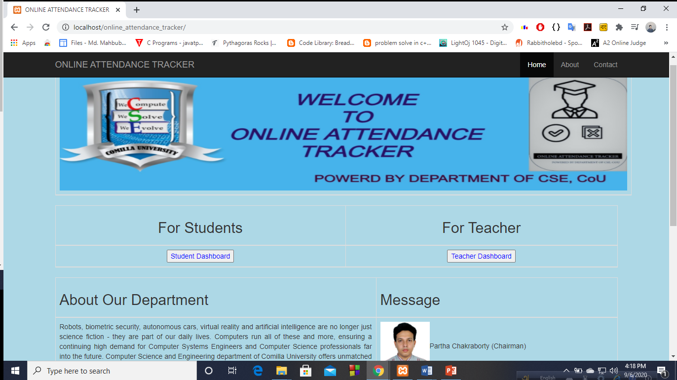

Fig 4.1: Homepage

Here the teacher will follow the teacher dashboard and student will follow the student dashboard.

15

When teacher will select teacher dashboard he/she will go in the following page:

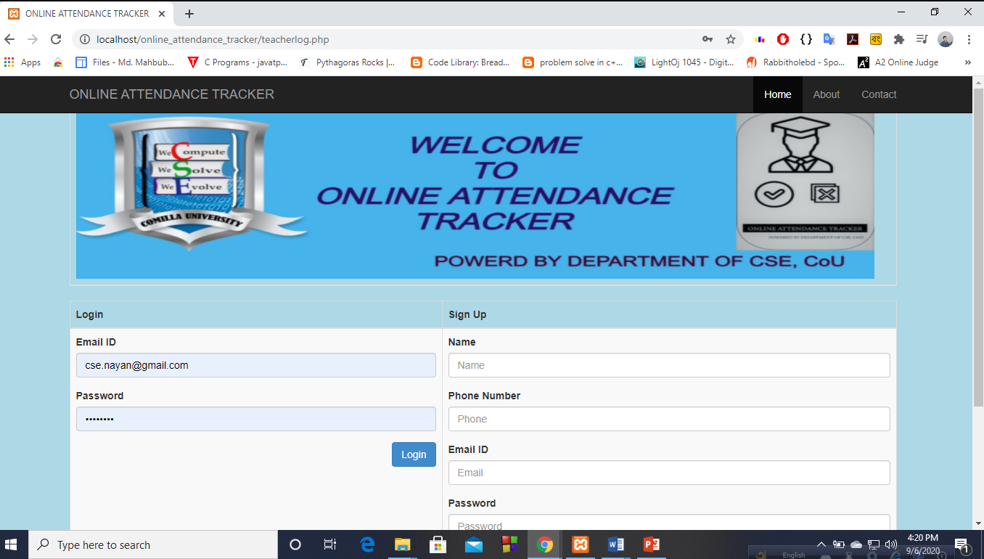

Fig 4.2: Teacher Dashboard

Here there are two options for the teacher. He/she can log in here for next, if he/she doesn’t do signup yet then it must need to do signup. Only faculty members can signup by using their valid email. After login, the teacher will be followed in the following page:

16

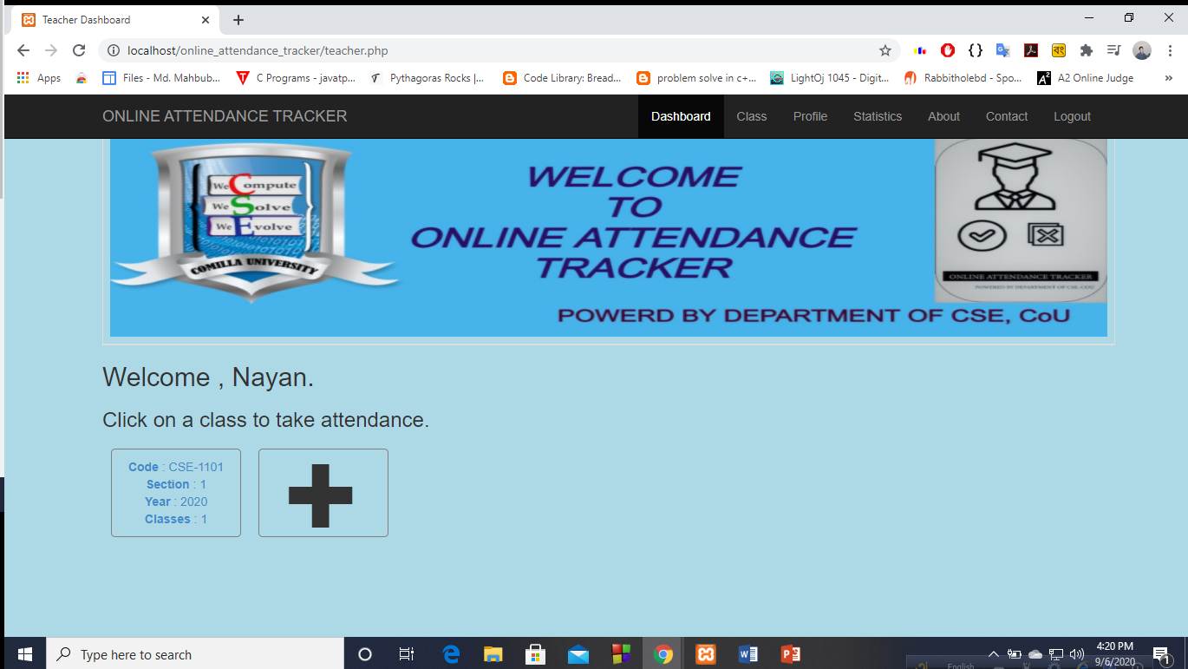

Fig 4.3: Teacher Homepage

Here teacher can add new classes, delete classes, update classes, update his/her profile. Teacher can do these works by following these pages: Here he/she can update his/her details.

17

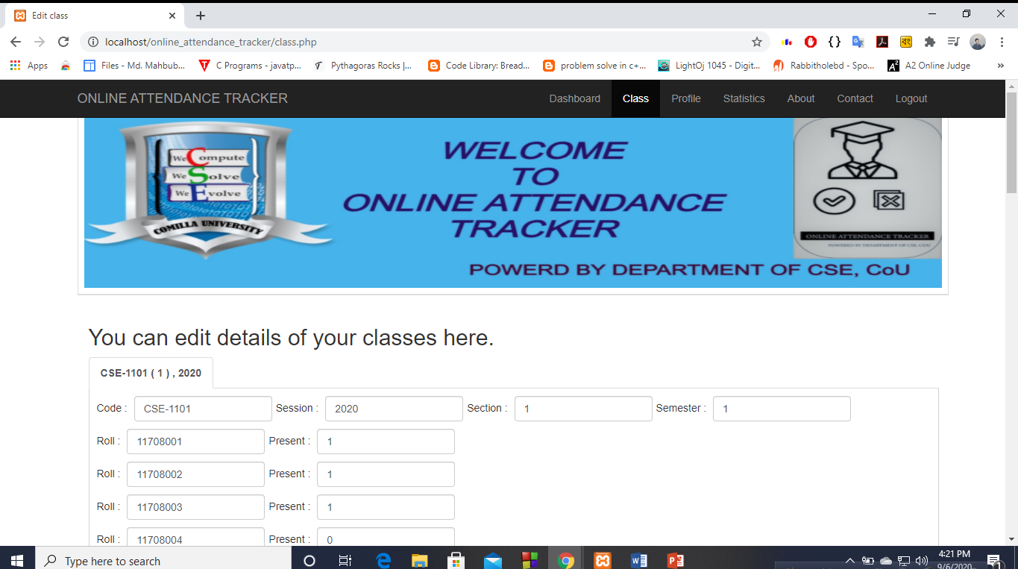

Fig 4.4: Editing classes

18

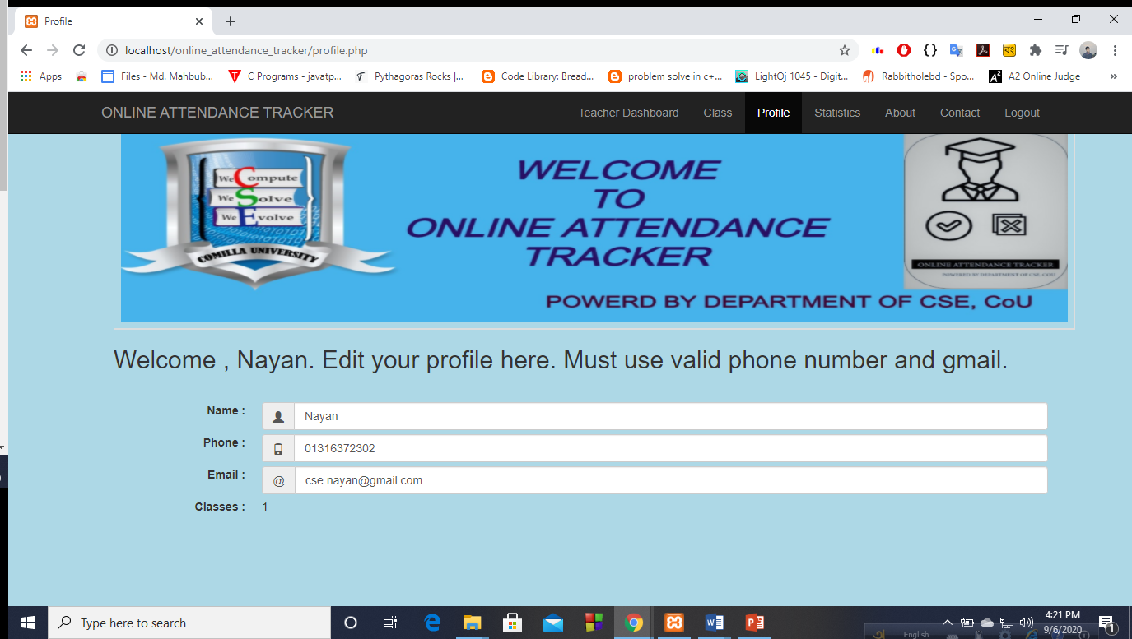

Fig 4.5: Update Teacher information

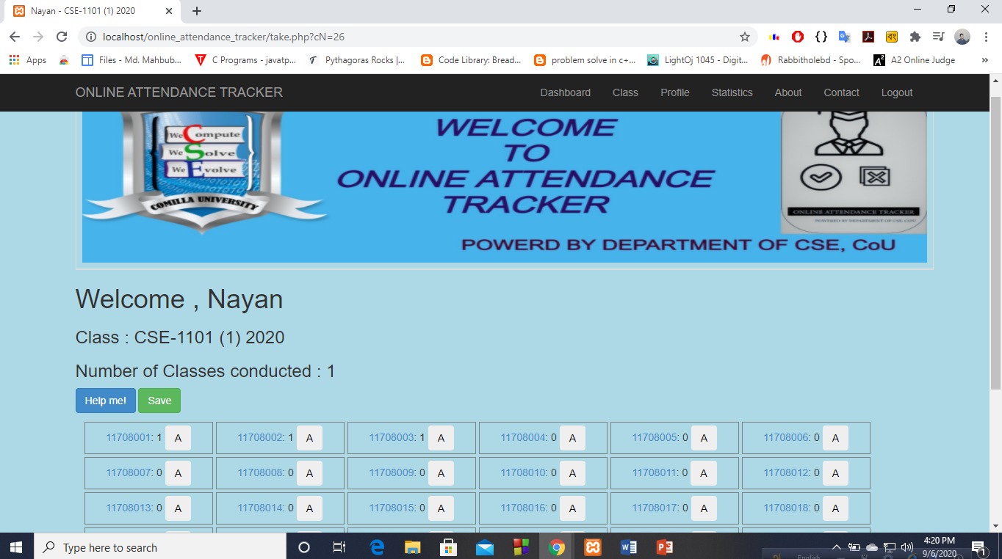

Fig 4.6: Attendance sheet

19

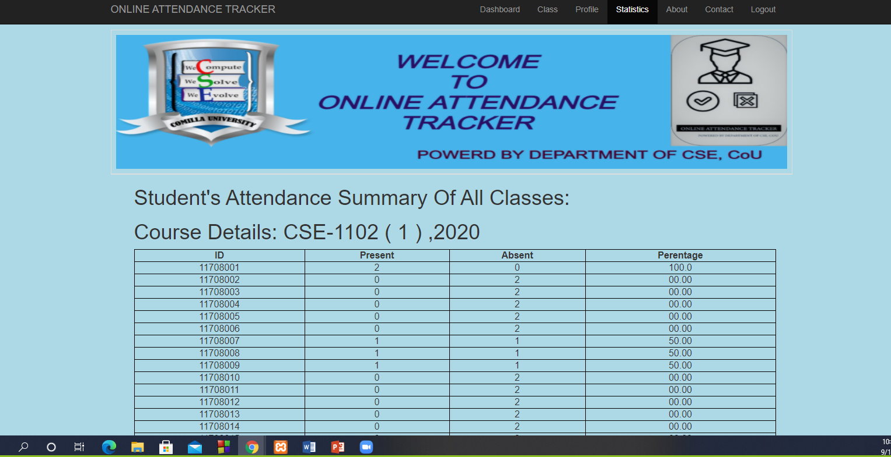

Fig 4.7: Student Statistics

When a student want to see his/her attendance details he will click on the student dashboard on the first page. Then he/she will be followed in the following page:

20

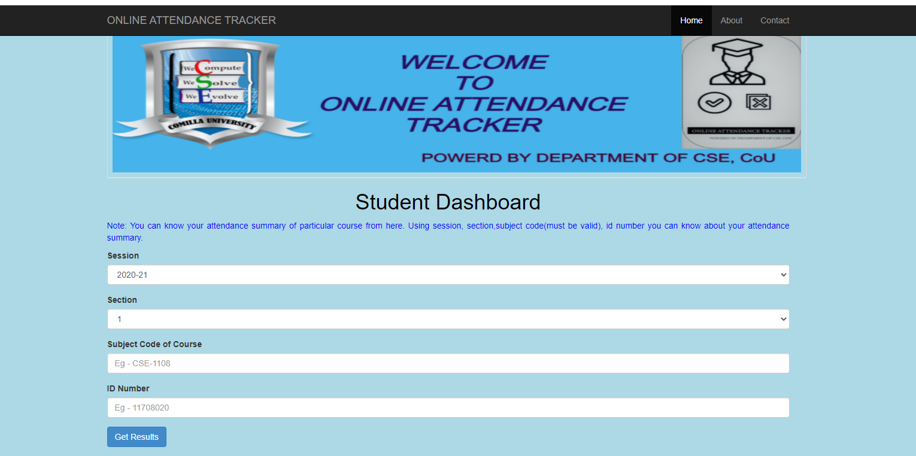

Fig 4.8: Student dashboard

Using valid session, code course, roll number they will see their details.

21

## Chapter 5

## Conclusion

"Online attendance tracker" can help both teachers and students. Teachers can easily maintain a student’s attendance. A student can also get about his/her attendance details by following this project.

There are some features that need to be included in this project in the future to make the website more efficient and fully functioning.

• We will try to add students the result of every semester here so that they can get there result easily.

• We will try to add a fingerprint here.

• We will try to add such an option so that if any student does less than 60% attendance then the teacher can notify him/her and their guardian.

22

**References**

1. <https://www.w3schools.com/css/css_intro.asp>

2. <https://www.webslesson.info/2019/05/online-student-attendance-system-project-in-php.html>

3. https://www.youtube.com/watch?v=QsAVoLPqkRQ&ab_channel=Programmin

gwithVishal

4. https://en.wikipedia.org/wiki/Entity%E2%80%93relationship_model

23